**Practical No: 4**

Page| 08

**Aim:** Write a program to implement various morphological images processing technique.

**Erosion:**

Erosion is the morphological operation that is performed to reduce the size of the foreground object. The boundary of the foreign object is slowly eroded. Erosion has many applications in image editing and transformations, and erosion shrinks the image pixels. Pixels on object boundaries are also removed.

**Program code:**

from PIL import Image

from skimage.io import imread

from skimage.morphology import binary_erosion, rectangle

from skimage.color import rgb2gray

import pylab

im=rgb2gray(imread(r'C:\Users\LJP_IT_LAB\Desktop\car.jpg' ))

im[im<=0.5]=0

im[im>0.5]=1

pylab.gray()

def plot_image(im,title=''):pylab.title(title,size=10)

pylab.subplot(1,3,1),plot_image(im, 'original')

pylab.imshow(im)

im1=binary_erosion(im,rectangle(1,5))

pylab.subplot(1,3,2),plot_image(im1,'erosion with recangular size (1,5)')

pylab.imshow(im1)

im1=binary_erosion(im,rectangle(1,15))

pylab.subplot(1,3,3),plot_image(im1,'erosion with rectangular sieze (1,15)')

pylab.imshow(im1)

pylab.show()

**Output:**

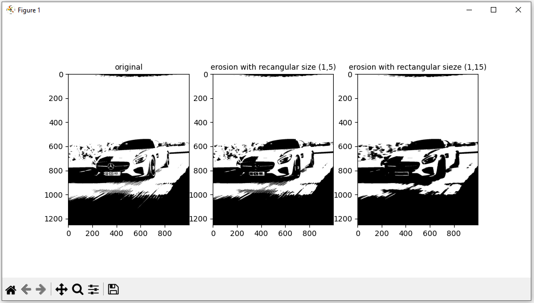

Page 00

**Dilation:**

Page| 09

Dilation of an image is the process by which the object area in the image is increased. This process is used to accentuate features in the image. It increases the white region in the image or the size of the foreground object increases.

**Program Code:**

from PIL import Image  
from skimage.morphology import binary_dilation, disk  
from skimage.color import rgb2gray  
from [skimage.io](http://skimage.io/) import imread  
import pylab  
im = rgb2gray(imread(r'C:\Users\LJP_IT_LAB\Pictures\pic.jpg'))  
im[im <= 0.5]=0  
im[im > 0.5] = 1  
pylab.gray()  
def plot_image(im,title=''):pylab.title(title,size=10)  
pylab.subplot(131),plot_image(im, 'original')  
pylab.imshow(im)  
for d in range(1,3):  
    im1 = binary_dilation(im, disk(2*d))  
    pylab.subplot(1,3,d+1), plot_image(im1, 'dilation with disk size' + str(2*d))  
 pylab.imshow(im1)  
 pylab.show()

**Output:**

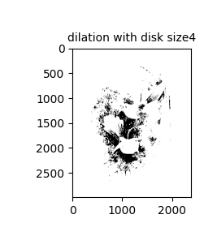

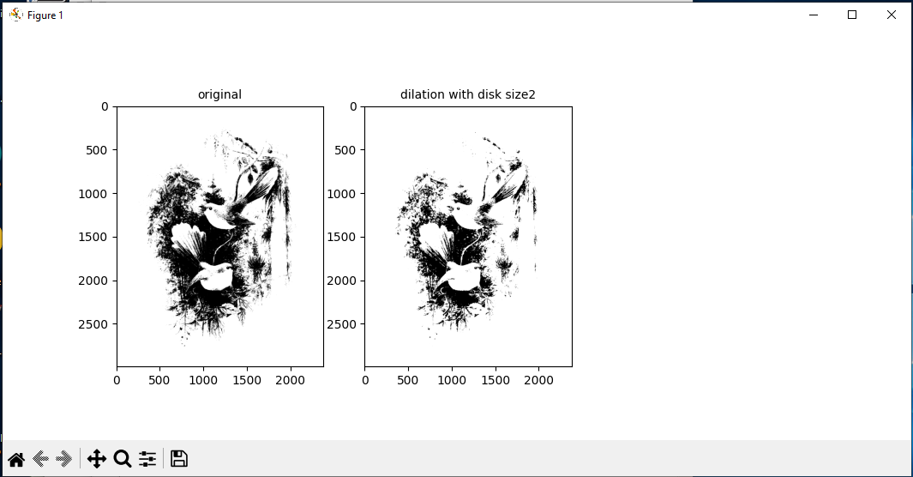

**Opening and Closing:**

Page| 10

Opening is a morphological operation that can be expressed as a combination of first erosion and then dilation operation; it remove small object from a binary image.

Closing, to the contrary, is another morphological operation that can be expressed as combination of first dilation and then erosion operation; it removes small holes from a binary image.

**Program Code:**

from skimage.io import imread

from skimage.morphology import binary_erosion, disk, binary_dilation, binary_opening, binary_closing

from skimage.color import rgb2gray

im=rgb2gray(imread(r'C:\Users\LJP_IT_LAB\Desktop\car.jpg' ))

im[im <= 0.5] = 0

im[im > 0.5] = 1

pylab.gray()

def plot_image(im,title=''):pylab.title(title,size=10)

pylab.subplot(1,3,1),plot_image(im, 'original')

pylab.imshow(im)

im1=binary_opening(im, disk(12))

pylab.subplot(1,3,2),plot_image(im1,’opening with disk size 12’)

pylab.imshow(im1)

im1=binary_dilation(im,disk(6))

pylab.subplot(1,3,3),plot_image(im1,’closing with disk sieze 6’)

pylab.imshow(im1)

pylab.show()

**Output:**

